ZOOKEEPER

ZooKeeper is a centralized service for maintaining configuration information, naming, providing distributed synchronization, and providing group services.

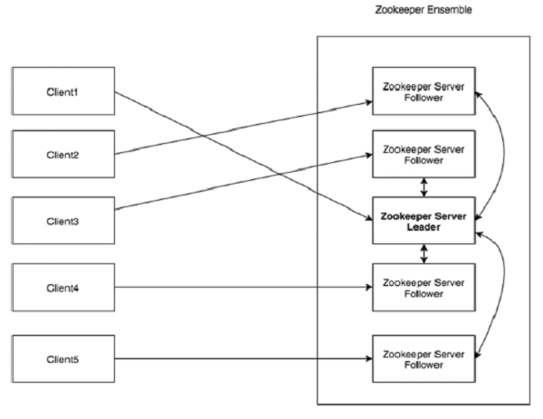

Leader | Server node which performs automatic recovery if any of the connected node failed. Leaders are elected on service startup.
Follower | Server node which follows leader instruction.

Ensemble | Group of ZooKeeper servers. The minimum number of nodes that is required to form an ensemble is 3.

Step1:Install java packages

install these step in all nodes

- sudo apt-get install software-properties-common
- sudo add-apt-repository ppa:openjdk-r/ppa
- sudo apt-get update
- sudo apt-get install openjdk-8-jdk
- java -version

link :http://askubuntu.com/questions/464755/how-to-install-openjdk-8-on-14-04-lts

STEP2:INSTALL ZOOKEEPER ON MULTINODES
- cd /opt
- sudo wget http://mirror.nus.edu.sg/apache/zookeeper/zookeeper-3.4.6/zookeeper-3.4.6.tar.gz
- sudo tar -zxvf zookeeper-3.4.6.tar.gz
- cd zookeeper-3.4.6/
- sudo nano conf/zoo.cfg #create file

tickTime=2000
dataDir=/var/lib/zookeeper/data
clientPort=2181
initLimit=5
syncLimit=2
server.1=172.17.0.2:2888:3888
server.2=172.17.0.3:2888:3888

- save it
- create a directory
- sudo mkdir -p /var/lib/zookeeper/data #it for data directory

in each system do this( create diffrent my id for each system)
- cd /var/lib/zookeeper/data
for 1st system

- echo “1” > /var/lib/zookeeper/data/myid #or create myid file content 1

for 2nd system

- echo “2” > /var/lib/zookeeper/data/myid #or create myid file content 2
if the third system it have myid will 3 etc.....

- cd /opt/zookeeper-3.4.6/
Finally start the zookeeper service,

- sudo bin/zkServer.sh start

Check your zookeeper whether is it running or not,

- sudo netstat -anplt | grep 2181

Servers listen on three ports: 2181 for client connections; 2888 for follower connections, if they are the leader; and 3888 for other server connections during the leader election phase .

We can check each status of nodes by

- cd /opt/zookeeper-3.4.6/
status of the zookeeper service,

- sudo bin/zkServer.sh status

- bin/zkCli.sh -server [ip or hostname or domain name ]:2181

some commands

note:there is 1 leader and more followers

- when its connected
- we can check the commands below

zkshell: 8] ls /
zkshell: 0] help
[zkshell: 9] create /zk_test my_data
Created /zk_test
[zkshell: 11] ls /
[zkshell: 12] get /zk_test

we can also check clustering by using this commands between different nodes

DOCKER FILE

FROM ubuntu:14.04

MAINTAINER pratheesh

run apt-get update
run apt-get upgrade -y
run apt-get install -y software-properties-common
run add-apt-repository ppa:openjdk-r/ppa -y
run apt-get update -y
run apt-get install openjdk-8-jdk -y

workdir /opt
run apt-get install wget -y
run apt-get install nano -y
run wget http://mirror.nus.edu.sg/apache/zookeeper/zookeeper-3.4.6/zookeeper-3.4.6.tar.gz
run tar -xzf zookeeper-3.4.6.tar.gz
add zoo.cfg /opt/zookeeper-3.4.6/conf/

workdir /var/lib/zookeeper/data/
run echo "2" > /var/lib/zookeeper/data/myid
expose 2181
entrypoint /opt/zookeeper-3.4.6/bin/zkServer.sh start && bash

zoo.cfg file

ubuntu@myregistrydomain:~/zookeeper$ cat zoo.cfg
tickTime=2000
dataDir=/var/lib/zookeeper/data
clientPort=2181
initLimit=5
syncLimit=2
server.1=172.17.0.2:2888:3888
server.2=172.17.0.3:2888:3888

